School of Pharmacy Compensation Plan FAQ
Which faculty must participate in the Compensation Plan? How does the Plan impact faculty members? As per University of California policy, membership in the Compensation Pan is a condition of employment for all faculty with appointments over 50 percent. The compensation plan defines obligations, process for disputes/ grievances, minimum salary levels, and additional leave benefits.

What are the components and basis of salaries for faculty?
Base Salary: The Academic Program Unit (APU) determines the amount of salary that is used in calculating retirement and benefits such as retirement (UCRP), life, and disability insurance. The APU also dictates the minimum salary rate that may be paid to a Plan Participant. The School of Pharmacy has only one APU and is on scale 3 of the Health Sciences Compensation Plan salary scales.
The compensation plan allows the payment of negotiated salary (Y) and incentive/bonus compensation (Z). “Y” salary may be annually re-negotiated with the Chair and the rate is effective July 1. “Y” salary not covered compensation for UCRP or other benefits. Factors considered in re-negotiation of the “Y” include academic performance, quality of work, productivity in areas of teaching, scholarly activity, clinical activity, research and service. Administrative Stipends are regular payments related to University administration that exceed normal responsibilities. “Z” payments are payments from revenue due to the Compensation Plan or annual incentives.
The School of Pharmacy plan allows participants to designate either a percentage or a flat dollar amount of funds due to the Compensation Plan that may be directed into an academic enrichment account. The designation must be made by the end of May for the following fiscal year. These funds remain with the University if the faculty member leaves the University.

What are the reporting obligations and limitations for Outside Professional Activities?
Outside Professional Activities, whether paid or unpaid or on leave, are activities that are within the faculty member’s area of professional, academic expertise. A conflict of commitment occurs when outside activities interfere with professional obligations to the University. The maximum time limit for full-time faculty to engage in outside professional activities is 384 hours or 48 days. The maximum amount that may be earned (earnings threshold) is 40K or 40% of fiscal year base salary (scale 0), whichever is greater. Faculty must disclose annually all time spent and income generated from Category I and II activities. Furthermore, they must obtain pre-approval for all Category I activities and if they anticipate exceeding the time limits or earnings threshold. Income earned beyond the maximum threshold is due to the Plan, as detailed in the Compensation Plan.

What is the basis and definitions for the categories of Outside Professional Activities?
The University of California requires that faculty owe their primary allegiance to the University. Outside professional activities are categorized based on the extent to which a conflict of commitment is likely to arise. Category I activities must be approved in advance of the activity because they require significant professional commitment. These activities include outside teaching, research, or administration of a grant, employment outside the University, assuming a founding or co-founding role of a company or assuming an executive or managerial position outside the University. Category II activities are generally of shorter duration and include occasional service other than patient care, additional University compensated teaching, University continuing health education or self-supporting degree programs, testifying as an expert witness, consulting to for profit and non-profit entities and to governmental agencies. Category III activities are within the scope of University employment and even if compensated do not require annual disclosure and do not count towards the time limit or the earnings threshold. Category III activities include serving on a government or professional panel, or as an officer or board member or a professional society, reviewing manuscripts, acting as an editor, attending and presenting talks at academic conferences and developing scholarly or creative works. Note: These activities do not require disclosure.
Examples of category I activities:
- Chairman of the Board, and/or founder of a private company
- Co-founder of a fee-for-service or biotech company
- Faculty teaching and/or coordinating a course in a non-UC affiliated professional program or University

Examples of category II activities:
- Consultant and/or expert witness for a private legal firm
- Scientific advisor or consultant for pharma, biotech firms, venture capitalist, publisher, health insurance company, non-profit academic institution
- Member of /or consultant to the scientific advisory board of a private company

All my consulting is on weekends, vacation or holidays. Do I still need to report them?
Yes. Faculty are exempt employees (therefore not on a fixed work week) and all Category I and II professional activity counts towards the time limit and earnings threshold and must be reported (regardless of day of the week or time of day in which the activity occurred).
What is “Good Standing”?
A faulty member should meet School/Department/Unit guidelines regarding productivity in research, teaching, patient care, mentoring, and University service as defined by their series, rank, and step. They are expected to demonstrate professional behavior and contribute to the overall success of their institution. Meeting these guidelines and expectations deems a faculty member in “Good Standing”.
To maintain Good Standing faculty must:
- Participate in assigned duties
- Comply with University policy and reporting requirements
- Obtain prior written approval for engaging in Category I activities or for involving a student in an outside professional activity
- Obtain prior written approval to engage in outside professional activities that may result in exceeding the annual time limit and/or the earnings threshold
- Maintain a running total of annual earnings from and time spent on all outside professional activities
- Maintain solvent X and Y funding sources
- Deposit into the Compensation Plan any income where the time or earnings thresholds have been exceeded
- Disclose any current or prospective outside professional activity to the Chair if in doubt as to whether there is a conflict of commitment
- Submit annual Outside Professional Activities reports

What are the consequences of a loss of “Good Standing” status?
Loss of Good standing may occur with the finding of faculty or research misconduct, unsatisfactory performance in a five-year review, loss of clinical privileges, licensure or credentials. Loss of good standing may also be the result of failure to generate salary support and/or shared expenses. The consequences may include prohibition from participation in or retaining income from outside professional activities, decrease or loss of negotiated or incentive compensation (Y and Z salary components), and denial of requests for academic leave. The Compensation Plan outlines an administrative review process for loss of good standing.

What are the paid benefits for disability, extended illness, childbearing or rearing, and bereavement leave?
- The School of Pharmacy purchases a supplementary disability insurance to cover “Y” salary. The benefit provides 66 2/3% of the “Y” salary in effect to a maximum monthly benefit of $15,000. The waiting period for this benefit is 180 days. If you think that you may need to use this benefit, contact the Dean’s Office.
- Extended Illness Benefit: Full-time faculty receive 180 days of full salary at the base (scale 3) rate. Part time faculty receive a benefit pro-rated by their appointment percent. Re-accrual is at the rate of one month per year until the full benefit has re-accrued. If the Plan Participant returns to work part-time, the leave is replenished based on the percent time worked.
- Childbearing Leave: 12 weeks of full pay (X’ +Y). Must be used within 12 months of the birth.
- Childrearing Leave: non-birth parents receive 12 weeks at the full pay rate. Must be used within 12 months of the birth or adoption.
- Other paid leave: 5 days to care for spouse, domestic partner, child, or parent.
- Bereavement Leave: 10 days for the death of a family member or person residing in the household. 5 days for the death of an individual who is not a family member or residing in the household.

How does School of Pharmacy’s extended illness leave pay and UC’s disability benefit interact?
- UC’s Short-term Disability plan provides up to 60% of your eligible monthly earnings, to a maximum benefit of $15,000 per month, up to 6 months. The Long-term Disability plan provides the same coverage after 6 months, until your Social Security retirement age for most conditions. Enrolling in the Long-term disability plan is a good option for faculty covered under the Extended Illness Benefit, or those who can cover household expenses for up to 6 months.
- If you are vested in UCRP and are of retirement age, will your retirement income provide you with at least 60% of your current covered compensations? If yes, you may not need to carry disability coverage.
- Below is an example of a Faculty member requiring a medical leave. Faculty X informs his Chair that he requires a medical leave effective July 1 and completes a leave of absence form to indicate a paid medical leave of absence. The table below shows how the extended illness leave would coordinate with the School of Pharmacy “Y” disability insurance and UC’s Basic and Voluntary Long-term Disability Plans. In this example, the Plan Participant is at the rank of Professor, step 2, scale 3. His total monthly salary is $14,000, which is comprised of covered compensation of $12,416.67 per month and “Y” salary of $1,583.33 per month. Fortunately, he has enrolled in the Long-term Disability Plan.
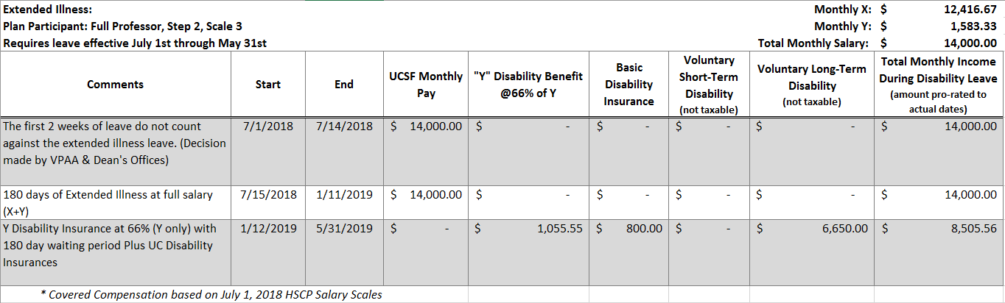

Who can I contact for advice about the Plan?
The Associate Dean for Academic Affairs, Thomas Kearney, can be reached by email, thomas.kearney@ucsf.edu, or phone, 502-2882. The Compensation Plan can be accessed at the School of Pharmacy Academic Affairs website http://pharmacy.ucsf.edu/deans-office/academic-affairs. In addition, there are 6 faculty members of the School of Pharmacy Compensation Plan Advisory Committee who can take your input on suggestions or concerns about the Plan. Their names and contact information is also provided on the Academic Affairs Website.

